**Task _1**

types distributions

1. Bernoulli distribution : has only two possible outcomes, namely 1 (success) and 0 (failure) take value 1 with the probability of success, say p, and the value 0 with the probability of failure, say 1-p.

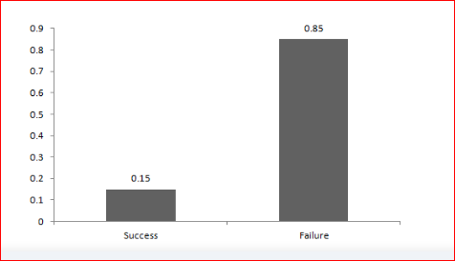

1. Uniform Distribution: Unlike Bernoulli Distribution, all the n number of possible outcomes of a uniform distribution are equally likely.

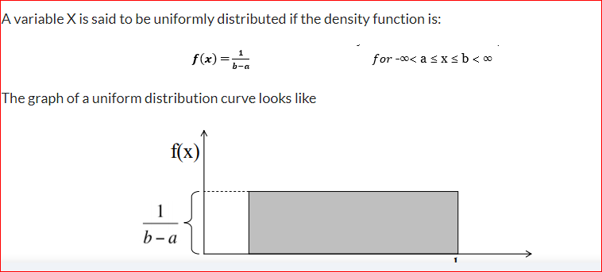

1. Binomial Distribution: A distribution where only two outcomes are possible, such as success or failure, gain or loss, win or lose and where the probability of success and failure is same for all the trials.

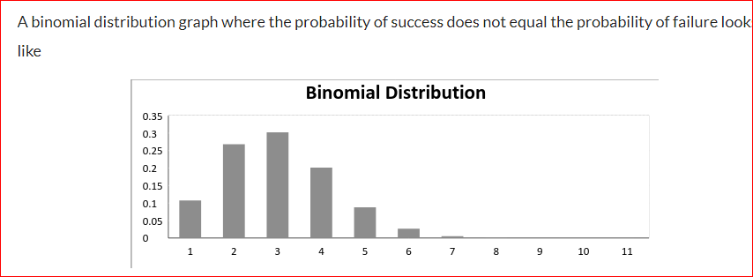

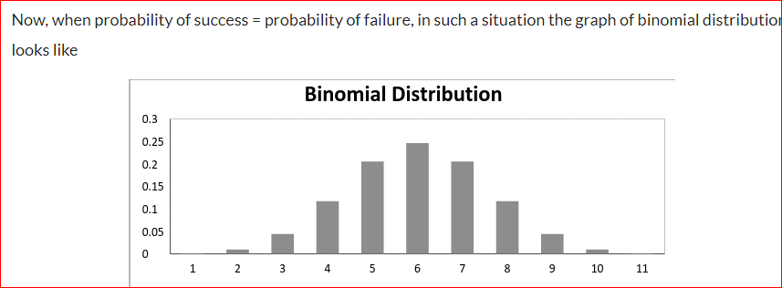

1. Normal Distribution :  Any distribution is known as Normal distribution if it has the following characteristics:
2. The mean, median and mode of the distribution coincide.
3. The curve of the distribution is bell-shaped and symmetrical about the line x=μ.
4. The total area under the curve is 1.
5. Exactly half of the values are to the left of the center and the other half to the right.

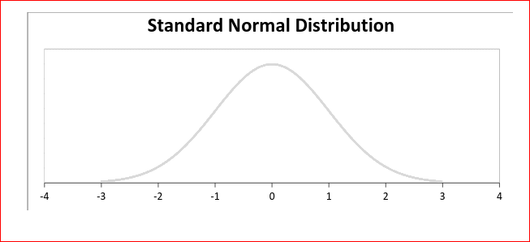

1. **Poisson distribution:**  is applicable in situations where events occur at random points of time and space wherein our interest lies only in the number of occurrences of the event.

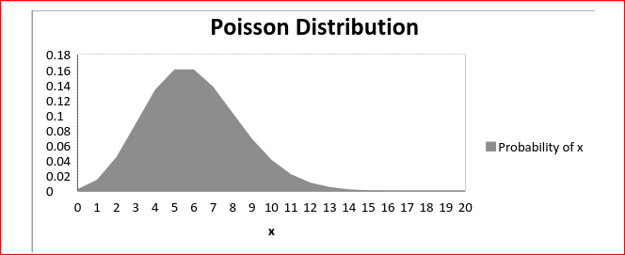

 the mean increases, the curve shifts to the right.

1. Exponential Distribution: Exponential distribution models the interval of time between the events.

Other examples are:

1. Length of time between metro arrivals,  
2. Length of time between arrivals at a gas station  
3. The life of an Air Conditioner

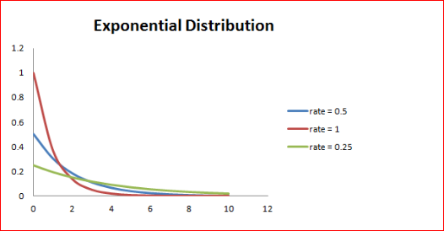

Task_2

How to convert from any type of distribution into normal distribution??!!

Transforming a non-normal distribution into a normal distribution is performed in a number of different ways depending on the original distribution of data, but a common technique is to take the log of the data.

Task_3

When we can’t remove the outliers!?!!

You don’t remove outliers unless they are errors in the data. Outliers can contain important information.

may have a very small data set and the model you choose is greatly affected by the outliers.

If your building machine learning models**, you ALWAYS remove outliers.**